Part A: Basic Questions
Program 1: Find last index of element
- The loop condition is i > 0 and this prevents the program from checking the index at 0. The function will incorrectly return -1 if the last occurrence of y is at 0.
- The input validation throws an exception before the faulty loop is even reached.
- The faulty loop is valuated but the program finds 3 at index 2 and returns immediately. There is no incorrect state that occurs.
- The faulty loop terminates at i = 0, skipping the final array element. The corrected loop would also examine index 0. This means the control flow is incorrect, but the result is still correct because 4 is not in the array.
- At the point where the faulty loop exists prematurely:
State | Faulty Programs | Correct Programs
x | [1, 2, 3] | [1, 2, 3]
y | 4 | 4
i | 0 | 0
Control flow | Exits loop | Enters loop body
Final return | -1 | -1

Code Execution:
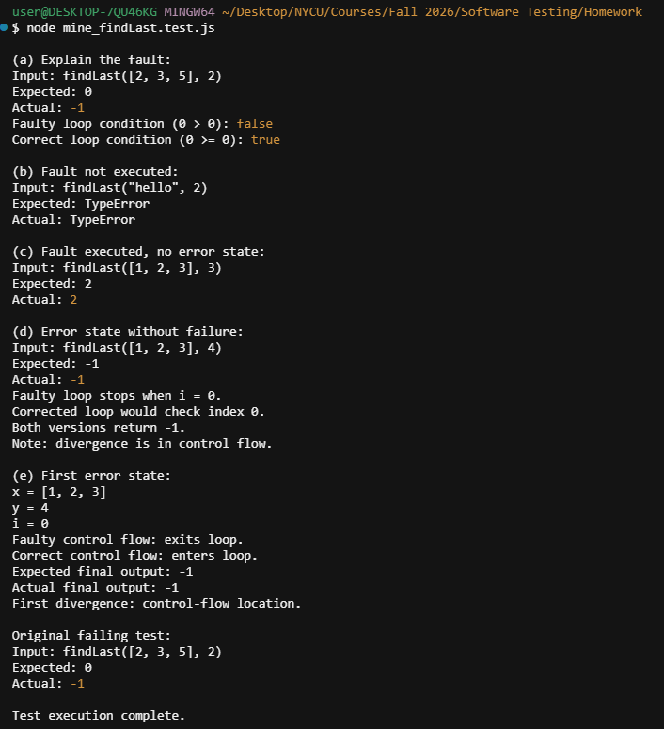

Program 2: Find last index of zero
- The function scans from the beginning of the array and returns the index of the first zero, rather than the last zero.
- The array is empty, so the loop body containing the faulty return statement is never executed.
- The function returns the first zero, which happens to also be the last zero. Therefore, the output is correct.
- Not possible for ordinary numeric arrays. If the array contains multiple zeros, returning the first zero produces the wrong index and therefore a failure. If it contains only one zero, returning that zero is correct.
- NA because no qualifying test was identified in (d).
Code Execution:
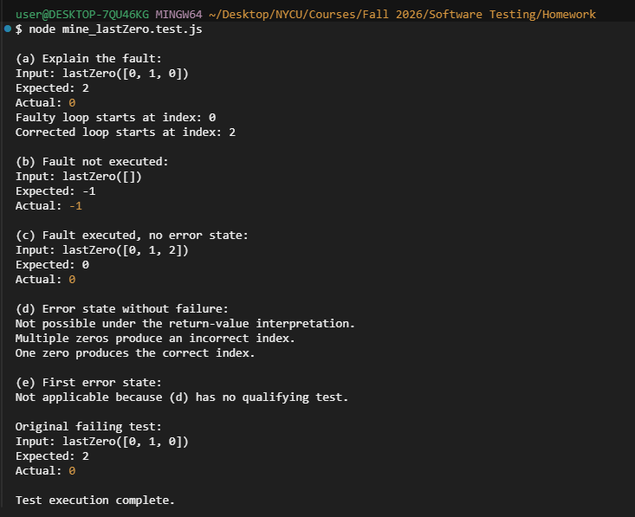

Program 3: Count positive elements
- The condition x[i] >= 0 incorrectly counts zero as a positive number. Positive numbers must be strictly greater than zero.
- The array is empty, so the loop and faulty condition are never executed.
- The faulty condition is evaluated, but the array does not contain zero.Therefore, the count remains correct.
- Not possible for ordinary numeric arrays. Whenever the array contains zero, the faulty condition increments the count incorrectly.
- Not applicable because (d) is impossible.
Variable | Faulty Program | Correct Program
x | [-4, 2, 0, 2] | [-4, 2, 0, 2]
count | 2 | 2
Code Execution:
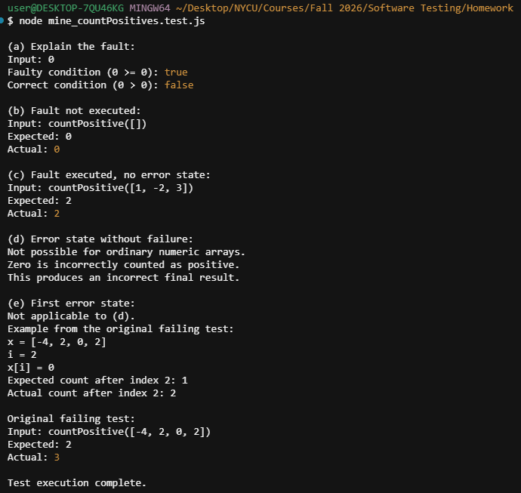
Program 4: Count odd or positive elements
- JavaScript's remainder operator % returns a negative remainder for negative odd numbers.
- The array is empty, so the loop and faulty condition are never executed.
- The faulty expression is evaluated, but there are no negative odd numbers. The correct values are counted.
- Not possible for ordinary integer arrays. Whenever a negative odd number is processed, the faulty condition fails to count it. So the final count is incorrect.
- Not applicable because no qualifying test case exists for (d).
Variable | Faulty Program | Correct Program
x | [-3, -2, 0, 1, 4] | [-3, -2, 0, 1, 4]
count | 0 | 1
Code Execution:
